978-1-5090-5256-1/16/$31.00 c 2016 IEEE

TCP/IP Remote Communication for Arduino based Motion Control using Virtual Instrumentation

Shital Patil1, Dr. D. V. Padole2 Student1, Professor2

Department of Computer Science & Engineering1, Department of Electronics Engineering2

G. H. Raisoni College of Engineering, Nagpur, India

# Abstract:

LabVIEW presented the structure technique in the LabVIEW stage, joined with Aurduino and TCP/IP convention for information obtaining and transmission of the long-range,and acknowledgment of the sign on the time-space investigation and on the recurrence area Analysis. Two PCs running LabVIEW simultaneously, ongoing information send and get between PCs by the interface of Virtual Instrument, which can understand multi-machine information transmission and perusing, so as to finish remote information sharing and controlling. LabVIEW stage gives a help to remote controlling and the observing of hardware. Proposed framework is gone for structure and advancement of remote research center exercises checking and controlling framework for movement control utilizing h-endlessness calculation.

.

**Keywords:** TCP/IP; h-infinity; Motion Control

# INTRODUCTION

Virtual examination about encouraging condition research has turned into another problem area in the flow training research. Virtual examination stage lessen the expense of research facility development. It principally depends on programming and less behind equipment. Safeguarding costs and the lab work were additionally incredibly diminished. System trial foundation of virtual instrumentation can be structure an assortment of virtual instruments as per the tests expect of different course. It can supplant conventional instruments to accomplish the research facility organize, just as it can diminish the expense of lab contraption, get the trial showing conditions and accomplish asset sharing. US National Instruments (NI) Company right off the bat proposed the virtual instrument (Virtual Instruments alluded to VI). The LabVIEW which speaks to the graphical advancement air isn't just incredible, yet in addition can proficiently diminish the expense of advancement applications. . With the improvement of system innovation and their applications, Acquiring system applications, which is on completely dependent on the virtual instrument (VI) innovation dependent on the LabVIEW is an investigation center in the present inside

In this paper equipment gadgets utilizes Aurduino Board and interface board. The LabVIEW stage acknowledge information accomplishment. With the end goal of movement arrange testing, and a reference PID controller and use of a few H-interminability (H∞) propelled control calculations {namely S/KS understanding, 1DOF and 2DOF Glover-McFarlane circle molding procedures} were symphonized and execute. From hypothesis (especially for movement control situating application) it very well may be seen that the pinnacle sizes of the affectability capacities can be related with the H∞ standard and the radiate results from these relations. In

McFarlane circle molding methodology [5] was picked, together with the decision of the pre-compensator and post compensator loads of the increased plant. That prompts the H∞ ideal issue plan, the augmentation of the consistency and the one-advance combination of the H∞ controller. The two-degrees-of-opportunity configuration comes as a characteristic continuation of the Glover-McFarlane circle forming methodology since it shows better results when the reference sign is dealt with unconnectedly from the deliberate input signal.

The fundamental objective towards the work is to plan a correspondence interface dependent on LabVIEW for movement control of part. The total sequential correspondence driver structure and execution and furthermore accomplish two different ways about system information transmission through TCP/IP. The strategy is adequately used to accomplish data to remotely control and access to nearby in succession ownership and showing. Information accomplishment and sequential correspondence naturally joined. Through web based testing it will be check work. Usage of information securing depended on LabVIEW correspondence framework with the ongoing correspondence and simple support for server and customer

The fundamental goal of the work is utilized of LabVIEW programming advancement stage, imparted to information obtaining cards like Arduino and TCP/IP correspondence convention to achieve a long-extend information accumulate and finished a period and recurrence space investigation. It contrasted and the straight information securing and handling framework, it has the benefits of a practical, high uniqueness, simple to-progress, information preparing simple, short advancement time, the utilization of excellent outcomes. This can be make the clients who don't have a lot of experience free out as of the overwhelming software engineers , attempt in the pilot testing, information examination and processing, performance testing.

# METHODOLOGY

1. **The easiest way Remote Desktop**

The most straightforward method for remote checking and control is to utilize Remote Desktop of Windows System rather than explicit understanding specifically application. As it were, The server-side is to be Windows XP, and the customer may utilize Windows 2000, Windows 98 and Windows XP. Remote Desktop establishes server-side and customer and can control each other framework.

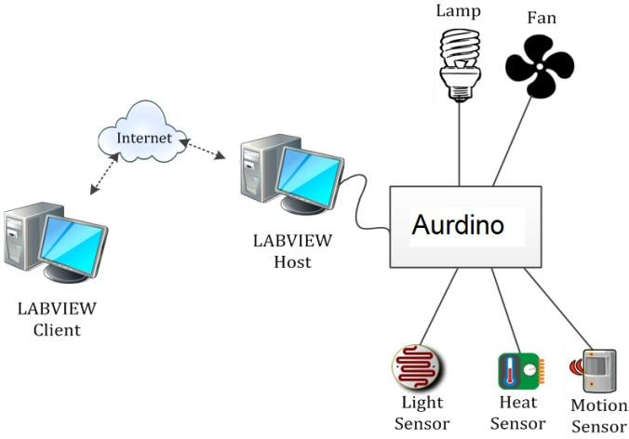

# Fig. 1 Internet Control of a Remote Laboratory

1. **The system hardware components**

The framework has two PCs, one server and other one is the customer. The server PC gathers information, store it for transmission later on and remotely control gadget parameters continuously; the customer work area get information , process it and show. The framework additionally use information transmission hardware, information procurement cards and sensors, for example, transport. Henceforth, this framework involves sensors, signal molding board, USB sequential transport, nearby information gathering PC, and transmission systems and remote information preparing and investigation PC.

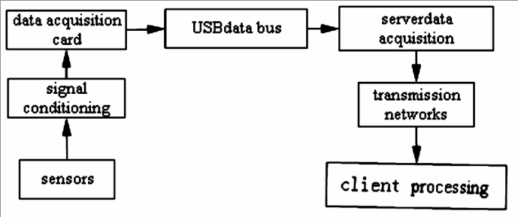

# Figure 2 The system hardware components

1. **To communicate use of the network protocol**

TCP/IP convention is essential and dependable Internet convention to control the progression of data utilizing web. LabVIEW underpins TCP/IP convention to accomplish information correspondences. There are two sub-format given for TCP/IP convention interchanges work, one is the TCP layout for capacities dependent on the TCP convention correspondences. The other one for capacities dependent on UDP convention interchanges called as UDP format Along these lines LabVIEW utilizes correspondence for remote information gathering between the customer.

# TCP transmission LabVIEW software

It accomplish TCP interchanges by utilizing distributed TCP module; it can plan server/customer method of correspondence. virtual Instrument customized has two sections: Client model managing the its principle acknowledgment of information fulfillment, its examination alongside information time and recurrence spaces investigation; Server model working for information securing, accomplished Data accumulation and transmission. In server, solicitation of the customer gotten by TCP Create Listen. After TCP association, TCP Write work hubs send information which thusly get moved to the system. At that point information get isolated int various sorts utilizing Type Cast hub work before sending to arrange.

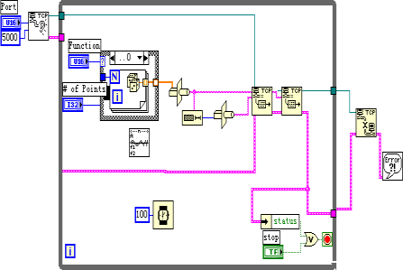

# Figure 3 . TCP / IP send procedure

# In customer, right off bat, utilized TCP Open Connection hub capacity to open a TCP association which remote port the server were assigned. TCP Read hub capacity get information transmitted by server and afterward tried and forms it. Port must be same during sending and getting process.

# Figure 4. TCP / IP receive procedure

1. **TCP / IP Network Communication Based On Labview**

. To set up two correspondence arranges between hubs we should build up correspondence interface between them, including both equipment and programming parts. The product part execute a correspondence convention. The interface equipment part accomplish physical association and data move between hubs. In the TCP/IP convention, the port is a structure, establishes unique information structures and cushions. Port capacity is same as to record I/O activities, the port can both be perused or composed . So as to explain Different sorts of correspondences between the host procedure, we require an opponent procedure of the system condition which can decide the port number and IP address.

# Server / Client based on LabVIEW

In customer/server model, a lot of customers demand for administration to

server. The functions perform by VI Client are given below:

1. Client program creates a connection with a server program;
2. Send orders to the server;
3. collect a response;
4. Close the connection.

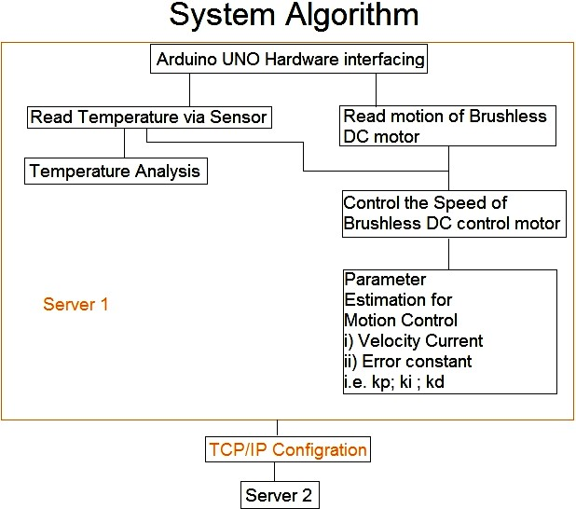

# Figure 4. Interfaces model

1. **DESIGN AND IMPLEMENTATION**

This narrative work based on the motion control parameter

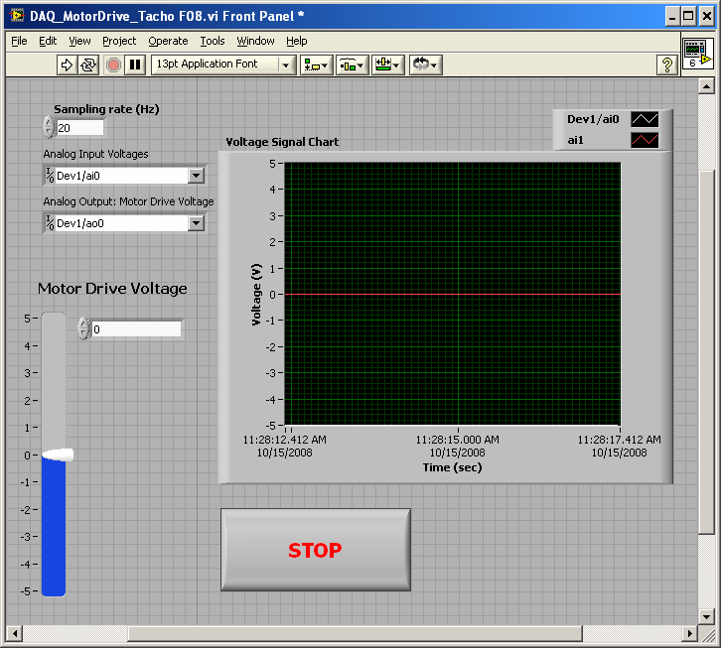

# Fig. 5. Motor drive control

1. **Control of DC Motor Velocity**

In this experiment, we will In this investigation, we will utilize a LabVIEW VI and an indispensable criticism control circuit to control a DC engine as appeared in Figures 5.1 . Scientifically, the indispensable (I) controller can be depicted in the time area as

*v*(t)  Ki *e*(n) dn

Where v(t) is the output and *K* is a constant gain

*I*

Where e(n) is the function of temperature.

1. *Proportional-Integral (PI) Control of DC Motor Velocity*
2. In this examination, we utilize a LabVIEW VI and a relative basic (PI) criticism control circuit to control a DC engine. Scientifically, the PI controller can be depicted in the time area as

*vPI* (t)  *Kp* e(t)  Ki *e*(n) dn

of Brushless DC motor as a controlling factor of temperature. The basic aim towards the implementation is h- infinity algorithm. Based on the control system the Change

Where *K*

*P*

and *K* are constant gains.

*I*

in temperature speed indicated the speed of DC Motor for motion control. In this laboratory, you will be write a LabVIEW program that will be permit you to drive on DC Motor by an analog voltage signal. You will be also learn how we can measure and view both angular velocity and angular position response signals from the motor. The DC Motor is a part of the MS15 DC Motor Controlling Module. The angular speed velocity of the motor can be controlled over using either an analog voltage signal pulse width modulated (P. W. M.) digital signal. In this laboratory, we will be use only analog signals.

In this remote laboratory, we will continue the investigating closed-loop feedback control of a DC motor. Your final goal is to control the DC motor such that the velocity (voltage)

# H-Infinity Algorithm

H-infinity (H∞) – present day control strategies in the H∞ space of grid esteemed capacities for scientific advancement and controller union, which accomplish ensured powerful execution or solidness.

.

output **V**

**OUT**

is an equal to a (desired) reference (voltage)

input **r.**

In Lab 6a, you build analog proportional (P) and integral (I) control circuits. We will be combine these circuits into a proportional-integral (P-I) control circuit.

# Fig. 6 LabVIEW Front Panel for Motion Control

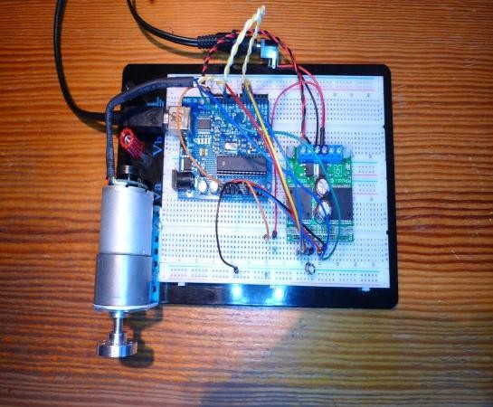

**Fig.6.3Experimental setup**

1. **CONCLUSION**

For remote association of the web-customer (speaking to the remote client) and movement control of the trial workbench are demonstrated plausible to be acknowledged – LabVIEW Web Services and Remote Front Panels. The utilization of LabVIEW programming improvement stage, joint with information obtaining and TCP/IP correspondence to achieve a long-run information gathering, and completed a period area sign examination and recurrence space examination. Contrasted and the built up information obtaining and preparing framework, it has the reward of a worthwhile, high all inclusiveness, simple to-advancement, information allotment straightforward, little improvement time, and the utilization of good result.